
ADVANCED AMIGA SOUNDCARD
mini

User Manual
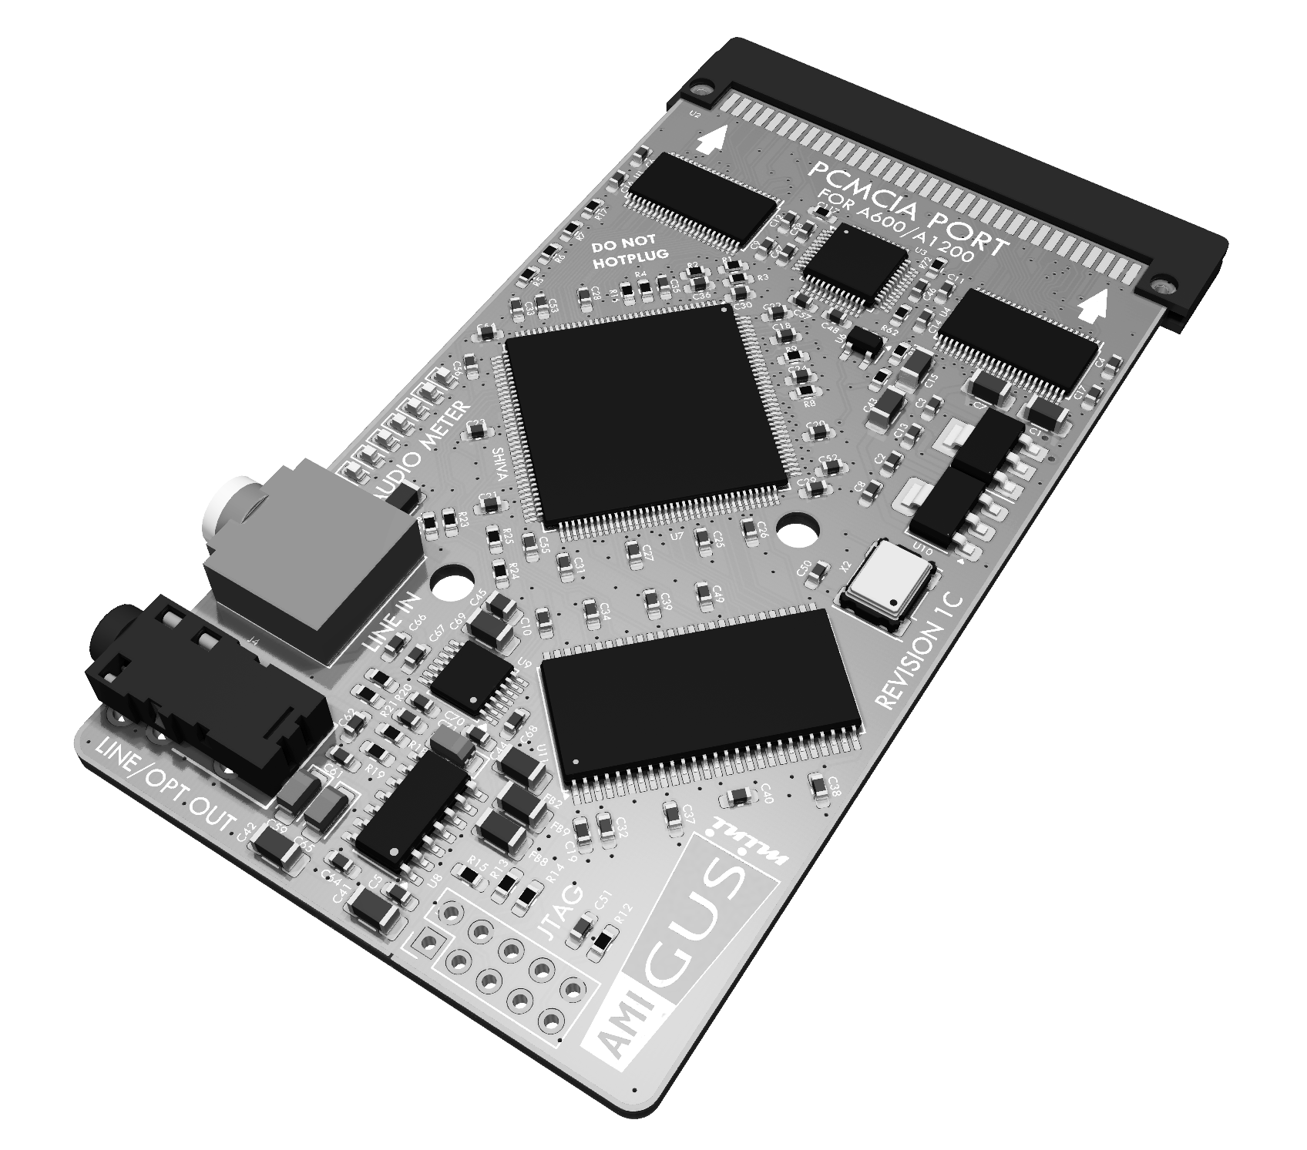


OLIVER ACHTEN
HARDWARE DESIGN BY
SOFTWARE DESIGN BY
CHRISTOPH FAßBACH
1 Overview 3
2 Installation 8
3 Software Tools 10
4 AHI Driver Framework 19
5 MHI Driver Framework 25
6 Driver Framework troubleshooting 30
7 Appendices 32

- Overview
  - Introduction

Thank you very much for purchasing the AmiGUS mini soundcard. It was designed to enable high-resolution audio playback on your Amiga computer. All audio processing makes extensive use of hardware acceleration in order to provide this quality even on low-end Amiga configurations.

  - AmiGUS mini Key Features

- PCMCIA bus interface for Amiga 600/1200 computers
- 24-bit, 192kHz stereo sample DAC
  - 1 combined analogue/optical 3.5mm stereo output
- 24-bit, 96kHz stereo sample ADC
  - 1 analogue audio 3.5mm stereo output
- mini TOSLINK optical output, supporting 48, 96 and 192kHz @ 24-bit resolution
- MP3 / OGG Vorbis hardware codec chip (VLSI VS1063)
- Digital sound processing accelerator chip
  - 3 separate software interfaces (AHI, MHI, MIDI/Wave)
  - 32 hardware voices
    - 8 / 16-bit playback
    - Stereo panning
    - Per-voice linear sample interpolation
    - Hardware ADSR envelope
  - Full 24-bit 192kHz processing and mixing paths
  - Hardware accelerated data transfers to / from DAC, ADC & MP3 chips
- 32 MB wavetable RAM
- LED-based VU meter, adjustable in sensitivity
  - Hardware Overview

In the following picture you can see an overview of the AmiGUS mini card, its interfaces and the main hardware components which provide the card’s functionality.

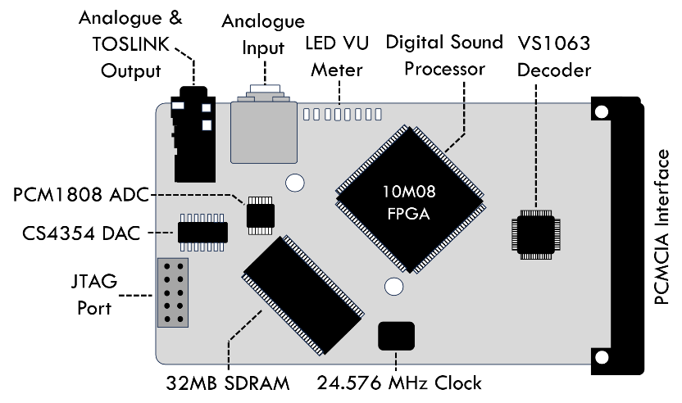
    - Hardware Ports

Port Name | Function
JTAG Port | Connects to an Altera FPGA programmer to flash and debug the FPGA. Should only be used for initial programming or servicing the card.
Analogue & TOSLINK Output | 3.5mm jack with combined stereo analogue / TOSLINK digital output, supporting up to 192kHz, 24-bit audio data rates in both modes.
Analogue Input | This port can directly connect to the AMIGA’s native PAULA audio signal, which is mixed and output with the AmiGUS mini final output.
LED VU Meter | Realtime display of the audio signal level, showing up to 128 levels of intensity.

    - Hardware components

Component | Function
Digital Sound Processor (SHIVA) | The Digital Sound Processor (SHIVA) is responsible for most of the digital sample processing and mixing. It directly connects to the Amiga’s PCMCIA bus and provides all necessary interfaces to the memory and audio support chips.
32MB SDRAM | This SDRAM memory chip can store up to 32MB of audio sample data for digital playback and mixing.
VS1063 Hardware Codec | The VS1063 is a hardware codec made by VLSI which supports hardware accelerated decoding of compressed audio streams such as MP3 or Ogg Vorbis.
PCM1808 ADC | The PCM1808 ADC made by Texas Instruments is responsible for converting all external audio inputs to a 24-bit, 96kHz digital stream which is processed and mixed by the Digital Sound Processor.
CS4354 DAC | The CS4354 DAC made by Cirrus Logic receives the final mixed digital audio stream and converts it to a line-level analogue audio signal. The audio data rate is always 24-bit, 192kHz.
PCMCIA Interface | AmiGUS mini implements a PCMCIA bus interface which maps only to the I/O area, supporting 8MB Zorro II Autoconfig expansions.
  - System Requirements

In order to make full use of AmiGUS mini features, the following range of system configurations is recommended.

    - Minimum Configuration
- Amiga 600 Computer
- 1 MB Chip-Ram
- 68000 CPU, 7MHz
- Kickstart 2.05

    - Recommended Configuration
- Amiga 1200 Computer
- 2 MB Chip, 4 MB Fast-Ram
- 68030 CPU, 25MHz
- Kickstart 3.x

Even though we ensure that the most essential Tools required to configure the card do work on all revisions of the Amiga operating system, using Kick 3.x is strongly recommended to yield maximum application compatibility.

- Installation
  - Card Installation

Turn-off your Amiga and insert the AmiGUS mini card into the PCMCIA port of your Amiga 600/1200, located on the left-hand side of the computer. Make sure there is enough room to accommodate for the additional space needed for the card itself and the cables.

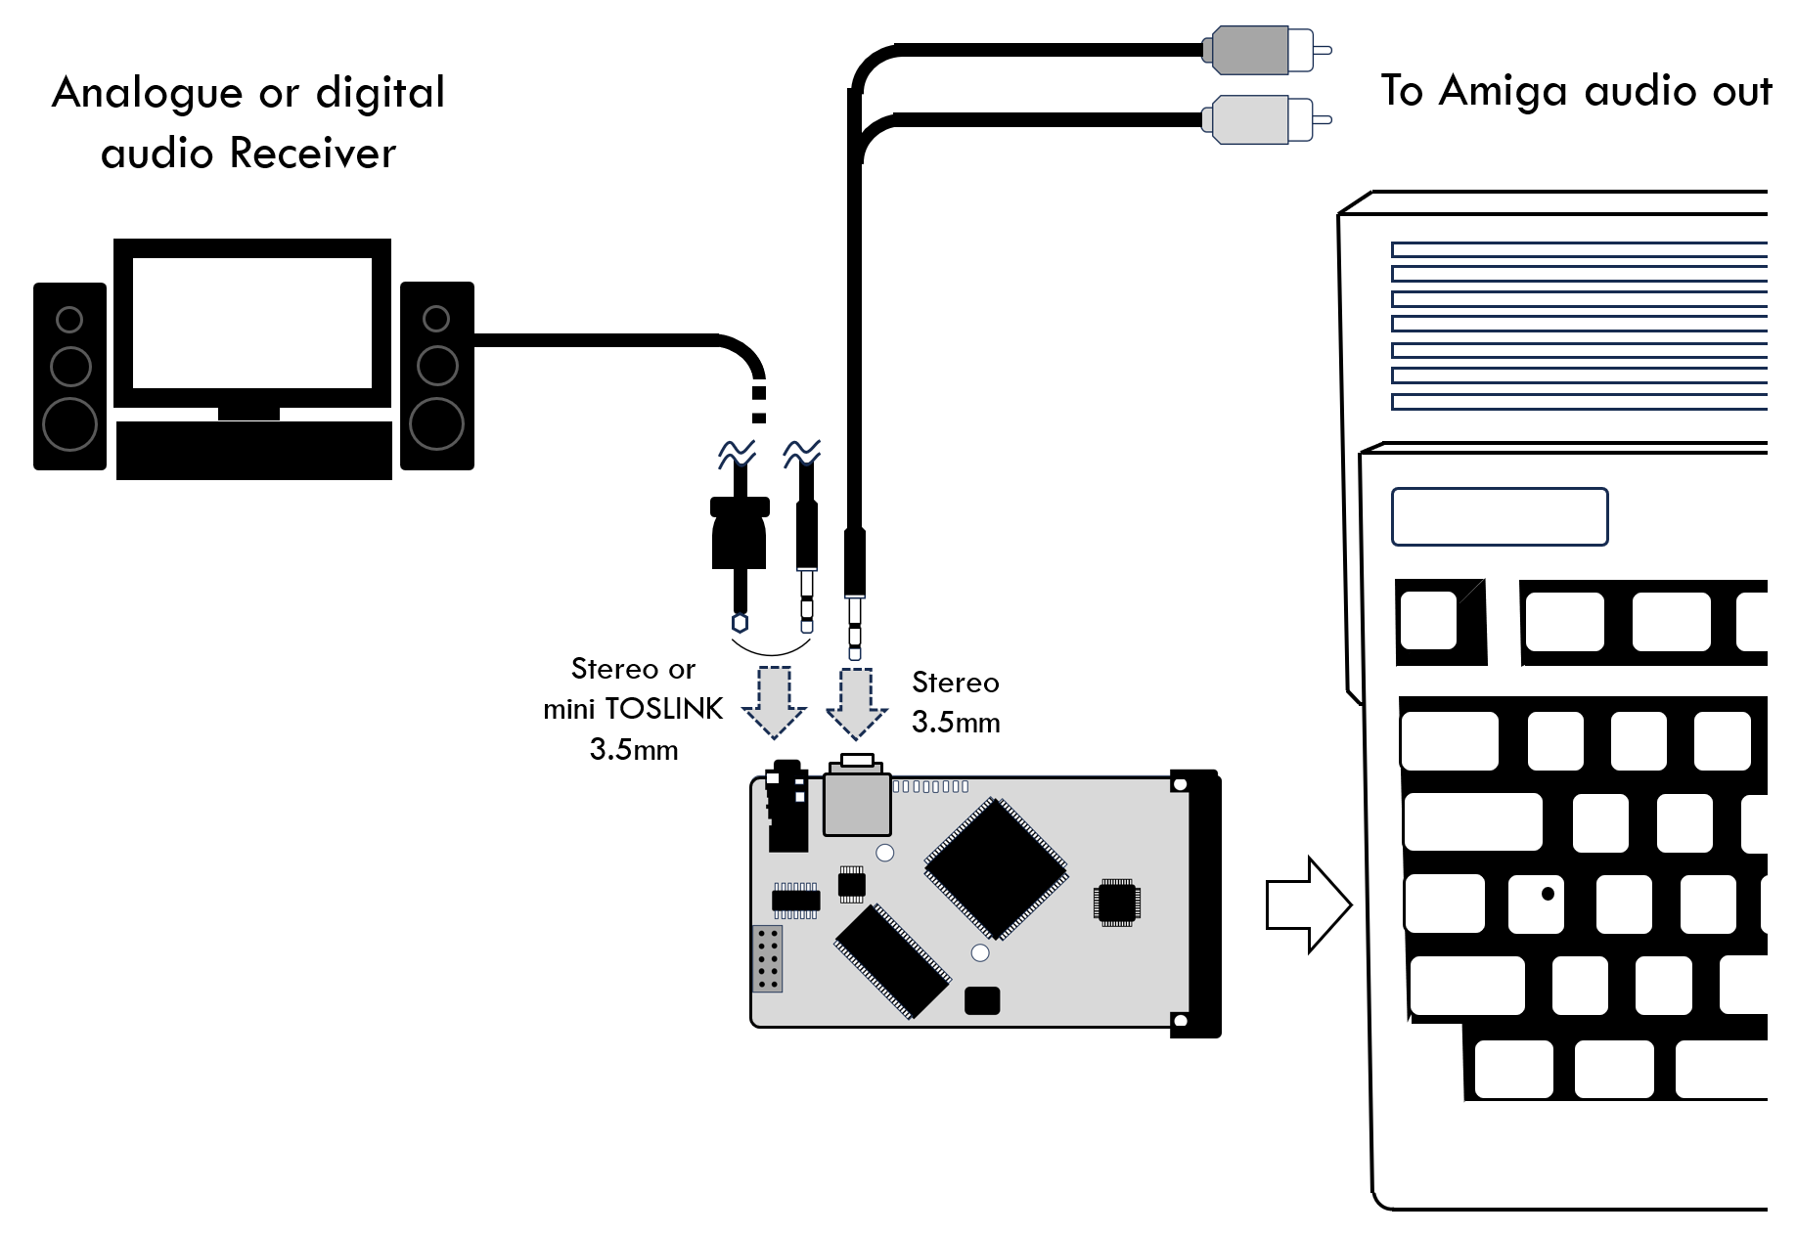

The AmiGUS mini card provides both a line-level RCA stereo output and a mini TOSLINK optical output on the same 3.5mm jack to connect to standard household analogue or digital stereo receiver equipment.

The TOSLINK output is very flexible and supports multiple sampling rates accommodating your output devices capabilities. The default output sampling rate is 48kHz, which should be compatible with all equipment providing a TOSLINK interface. Output rate can be adjusted in the mixer settings.

The analogue input can be used to loop-through the Amiga’s external audio output by using a Cinch-to-3.5mm adaptor cable, or to connect any other analogue sound source which supports line-level audio output.

- Software Tools
  - Installation
The AmiGUS mini software comes in the following packages:
- As LHA archive for OS2.x/3.x
- As sets of ADF files for OS2.x/3.x including one Manual Disk

    - OS2.x / 3.x Installation
On OS2.0 and later, the AmiGUS mini software installation relies on the Amiga Installer being available, which is part of the AmigaOS installation since OS2.1
Therefore, if you are installing the AmiGUS mini software on OS2.0, you may need to install the Installer from:
https://aminet.net/util/misc/Installer-43_3.lha
While we successfully tested the installation with an early Installer from OS2.1, Installer 43.3 is recommended in case you experience any kind of issues..
Similarly, to read the provided documentation in AmigaGuide format on OS2.0 and OS2.1, you will need to install the "AmigaGuide Development" version from:
https://aminet.net/text/hyper/aguide34.lha
The AmiGUS mini AmigaGuide manual has been designed to look best using OS3.2 and above, but you can at least conveniently read it using an older version.
The installation comes in multiple languages, but if you would like to see the installation procedure or the manual translated to other languages, feel free to reach out to us via our github presence.
The following installations are available:
Novice User
Installs all recommended parts without further modifications to the recommended file destinations. This should work fine for most users.
Please Note:
- If you change your CPU after installation and experience issues running any AmiGUS mini software, you may need to reinstall the drivers.
- The default installation path of AmiGUS mini tools and manual is Sys:Expansion/AmiGUS. This path may collide with some versions of Commodore's Janus bridgeboard software. If you experience any issues, please delete the AmiGUS mini software installed to that location, reinstall and select another path.
Intermediate User
Here, you may pick and choose a lot of options. For more details, please refer to the help texts embedded into the Installer when pushing the "Help" buttons when available.
Expert User
In addition to the above, only "Expert User" level installations allow for placing all CPU or debug versions of AHI and MHI drivers next to the activated ones.
Please keep in mind, using AHI and MHI requires additional software. Refer to sections 4 AHI Driver Framework and 5 MHI Driver Framework for a detailed description.
  - Mixer Tool

The AmiGUS Mixer Tool provides individual volume control over the various sound sources being processed and mixed by the digital sound processor.

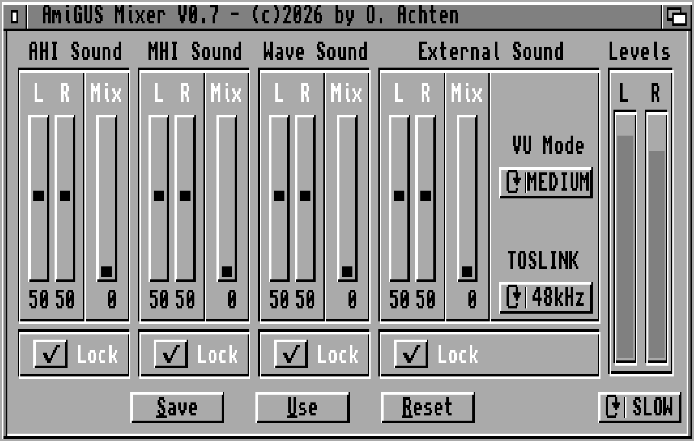

Across the panels, you can adjust the volume using the Left / Right volume sliders for channel-independent control. When the Lock button is enabled, Left /Right are always set to equal values when the sliders are changed.

By using the Mix slider, it is possible to cross-mix the stereo audio signal, thus lessening the amount of channel separation.

    - Mixer Panel Descriptions
Below you will find a description of each panel’s functionality and configuration options.

Panel | Description
AHI Sound | This panel provides volume control over all sounds which are played back using the AHI driver framework.
MHI Sound | This panel provides volume control over all sounds which are played back using the MHI driver framework, output by the VS1063 audio codec.
Wave Sound | This panel provides volume control over all sounds which are played using the 32 voice wavetable engine.
External Sound | VU Mode  You can either turn-off or adjust the sensitivity of the external VU meter by clicking and cycling through the options.  TOSLINK  By clicking on the cycle-gadget, you can set the audio sample rate of the TOSLINK output. Available options are 48kHz, 96kHz and 192kHz.
Levels | Realtime display of the stereo audio signal levels. By clicking on the cycle gadget below, you can control the display’s update rate.
Save / Use / Reset | Save, Use or Reset the Mixer settings to their default values. The settings are automatically loaded when the Amiga is started or reset.
  - AmiGUS Flash Tool

The AmiGUS Flash Tool provides full control over the AmiGUS mini FPGA firmware settings.

This includes updating the firmware, displaying the card’s hardware status or initialising the configuration data used for the mixer settings.

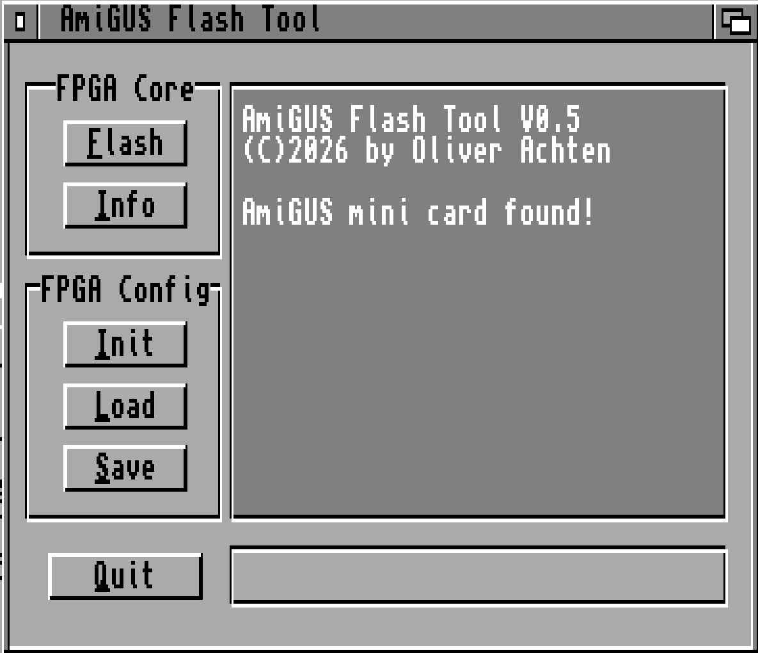

    - Available Options

Panel | Description
FPGA Core | Flash  You can directly update the AmiGUS mini firmware by clicking on this button and selecting the appropriate FPGA .upd file. Once an update file is selected, you can follow the update progress on the status bar below, which can take up to 30 seconds. The firmware update becomes effective after power-cycling the Amiga.  Info  Displays information about the FPGA revision, serial number and the state of the card’s configuration, containing the mixer settings.
FPGA Config | Init  Initializes the card’s mixer settings to their default values. This should be selected in case the card’s sound output is not correct. The settings become effective after a reset.  Load  Loads the card’s mixer settings from file, and flashes them to the internal configuration flash. The loaded settings become effective after a reset.  Save  Saves the card’s mixer settings to a file, which can be re-flashed by using the Load option.

- AHI Driver Framework
AHI is a retargetable audio subsystem for Amiga-like operating systems, originally developed by Martin Blom.
Not only have major audio applications, like SoundFX and DigiBooster adapted this standard, but many PC/Windows ports, Mac emulators, and even some exclusive software titles have implemented their audio functionality employing AHI to allow use of sound cards for playback and recording.
Although AHI 6.0 is available for download, AHI 4.18 is assumed to be faster and therefore strongly recommended for use on 68k-based systems. You need choose one of them and install it following their respective own manuals.
Before configuring AHI for use with AmiGUS mini, please verify that AHI is working correctly. AHI comes with a Paula driver which is sufficient for that purpose.
Please note:
- AHI 4 requires AmigaOS 2.0 or later to work.
- The AHI 4 preferences editor shown below uses MUI 3.8,
the non-MUI version works in a similar fashion.
- AHI 6 (not recommended) requires a 68020 processor or better.
- Due to limitations of the AHI framework, AmiGUS mini’s AHI driver is limited to a 64000Hz mixing rate.

  - Using AHI with AmiGUS mini

AHI shall be your last resort for making software use your AmiGUS mini.
- For playback of encoded music like MP3, FLAC, or OGG, please use MHI and let AmiGUS mini Hardware Codec do the heavy lifting,
- For tracker music, use a player with native support for the AmiGUS mini wavetable engine, e.g. HippoPlayer or EaglePlayer.
- If none of the above works for your application – here comes AHI. And only here.
  - Selecting AHI modes

AHI modes need to be carefully selected to fit the purpose.
Example: Quake (clickboom) mixes audio in 16bit, 11025 Hz.
- If you select an 8-bit audio mode, you lose playback quality.
- If you select a 24-bit audio mode, you waste precious CPU time.
- If you select a sample rate less than 11025 Hz…
well, you will not want to hear it anyway.
- If you select more than 11025 Hz, you waste resources again.
- If you do not at least select a multiple of 11025 Hz (like 1x, 2x, 4x), you force AHI to re-render the audio stream,
wasting even more CPU time.

But how do you determine the right AHI settings?
AmiGUS mini comes with an overwhelming number of choices.
Here are some guidelines:
- If your game or application displays resolution (“…16-bit…”) and sample rate (“…44.1kHz… ” or “…11025Hz…”) information, please use that information to adapt the AHI mode accordingly.
- Otherwise, for PC ports, 16-bit resolution and 44100 Hz are usually fine.
- “Mono” modes do not save a lot of CPU time, avoid them.
- “Stereo” modes know “left” and “right” and nothing inbetween. This is fine for PC ports, as they will apply their own mixing.
- “Stereo++” modes allow positioning instruments between the “left” and “right” extremes, but these are useful only if the client software can use it. PC ports usually cannot, and you may waste resources here. DigiBooster for example can benefit from it.
- “Fast…” modes take a bunch of shortcuts, saving a lot of CPU time, but potentially harming the audio quality, if you do not hit the correct resolution and sample rate – really recommended if you are sure about both settings!
- “HiFi…” modes are optimized for best possible quality and slower.
Avoid them for games, if you are short on CPU time, but recommended for enjoying music as good as possible!

  - Configuring AHI for AmiGUS mini

After all that theoretical foundation, you are ready to select AmiGUS modes using the AHI preferences editor usually installed to Sys:Prefs/AHI. Please start it from there by double-clicking on its icon.
Recommendations:
- Define a dedicated music mode, using all AmiGUS mini can deliver,
“HiFi 24 bit stereo++” in 48000 Hz, and use it only for music.
- Define some game modes, “Fast 16 bit stereo” in 11025 Hz, 22050 Hz, and 44100 Hz each and use them for your favourite PC ports.
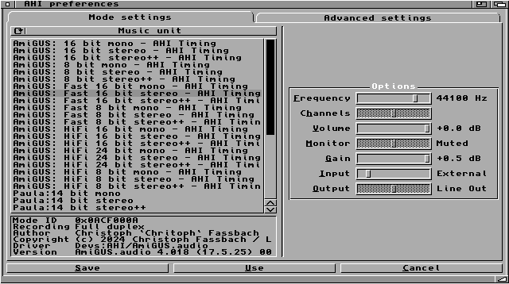

    - Available Options

Panel | Description
Left | AHI unit toggle (Music unit / Unit 0 / … 1 / … 2 / …3)  AHI supports defining up to five preset modes, the default “Music unit” and the units 0, 1, 2, and 3.  AHI Mode list  We love Paula, but this is about AmiGUS mini. So AmiGUS should be selected as the default input/output device from the list.  Mode details  Informational display only, but if the text looks broken or is empty, you know something is very wrong.
Right (Options) | Frequency  Select the desired sample rate using the slider.  Volume  Recommendation is to move the slider to the far right, +0.0dB and use the AmiGUS Mixer to adapt the volume to your needs.  Gain  Sets the input gain – recommended to set to +0.0dB, too.  Input  Selects the audio sources to record.  AmiGUS mini AHI driver allows recording Wave, MHI / Codec, external sound, and “what you hear” / all sources for the time being.

Buttons | Save  Applies all changes, stores them permanently, so they survive a reboot and closes the AHI preferences editor.  Use  Applies all changes and closes the AHI preferences editor, without saving the settings permanently. Can be used for testing.  Cancel  Discards all changes and closes the AHI preferences editor.

- MHI Driver Framework

MHI is a standard for retargetable encoded audio for classic Amigas.

AmiGUS mini comes with the VLSI VS1063a audio codec chip supporting
- MP3 (MPEG 1 & 2 audio layer III, with CBR, VBR, and ABR)
- MP2 (layer II)
- MPEG4 / 2 AAC-LC (with PNS), HE-AAC v2 (Level 3) (SBR + PS)
- Ogg Vorbis
- FLAC
- WMA 4.0/4.1/7/8/9 all profiles (5-384 kbps)
- WAV (PCM, IMA ADPCM, G.711 (µ-law/A-law), G.722 ADPCM)

Unlike AHI, MHI comes without separate system-wide preferences. Each application implements their own way of setting and selecting the desired MHI compatible library for the installed hardware.
Per default, AmiGUS mini’s MHI driver is installed to Libs:mhi/mhiamigus.library on AmigaOS 2.0 or later.

  - Example: MHI in AmigaAmp

As Thomas Wenzel not only created AmigaAMP but has also been co-authoring MHI, integration of both works almost perfectly, including equalizer functionality.

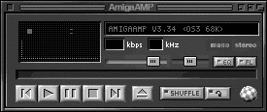

After starting AmigaAMP, open the Preferences via the Project menu entry.
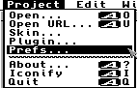

In the Preferences, navigate to the Decoder tab, select the “MHI Support” checkbox and click the file symbol next to the “MHI Driver:” label.
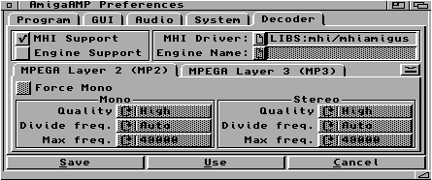
Navigate to Libs:MHI and select the mhiamigus.library. Library names are case-sensitive.
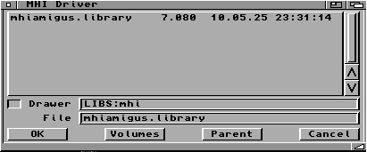
Confirm with the “OK” button, then close and confirm the preferences dialog with the “Save” button. You may need to restart AmigaAMP immediately.
Add a few mp3 files to your playlist and enjoy!
  - Example: MHI in HippoPlayer

HippoPlayer by K-P Koljonen supports AmiGUS mini’s wave table engine natively for tracker module playback starting with version 2.62 or later.
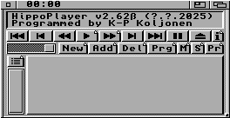
Click the “Pr” button to open the HippoPrefs window.
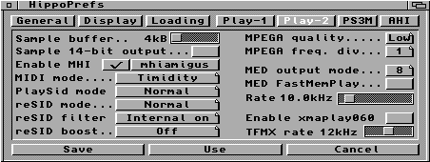
Navigate to the “Play-2” tab, select the “Enable MHI” checkbox and push the “mhiamigus” button right next to it shown above.
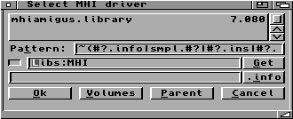
Navigate to the mhiamigus.library in Libs:MHI. Select it, push the “OK” button, save the preferences using the “Save” button.
Add a few mp3 files to your playlist and enjoy!

- Driver Framework troubleshooting
amigus.library, AHI and MHI drivers come with release and debug versions. Never use the debug versions for normal operations – they may introduce more crashes and are slower.
- “…-SER_LOG” versions of the drivers log to the serial port of the Amiga. You may use Sashimi to redirect the output back into a Workbench window, but the speed of that debug output is limited, and therefore the level of detail as well. A real null-modem cable can be used to get the output to another computer. Please find a link to a tested wiring at .
- “…-FILE_LOG” versions of the drivers log to a file on the Amiga. By default, this is “RAM:AmiGUS-?.log”, but can be adapted on AmigaOS 2.0 and above using
“setenv AmiGUS-LOG-FILEPATH SYS:amigus_lib_log.txt”, or
“setenv AmiGUS-AHI-LOG-FILEPATH SYS:my_AHI_log.txt” or
“setenv AmiGUS-MHI-LOG-FILEPATH SYS:another-Log-MHI.txt” respectively. Please be careful to not overwrite important files and be prepared in the event your drive may want to validate for a long time in case of crashes!
- “…-MEM_LOG“ debug versions of the drivers allocate a chunk of memory and leave their messages in there. This is as fast as it can be and as noisy as it can get, survives crashes well and will be requested in case of bug reports.
“setenv AmiGUS-LOG-ADDRESS 1234560”, or
“setenv AmiGUS-AHI-LOG-ADDRESS 1234560” or
“setenv AmiGUS-MHI-LOG-ADDRESS 1234560” sets the log address in case the automatic methods fail. Beware, the addresses are noted in decimal. The memory size can be adapted to fit your machine using
“setenv AmiGUS-LOG-SIZE 512”,
“setenv AmiGUS-AHI-LOG-SIZE 512” or
“setenv AmiGUS-MHI-LOG-SIZE 512” with a decimal memory size.
Beware: this is just for allocation and protecting the resulting logs. The drivers do not stop producing more logs behind the end of that memory slab.
Even after a crash, the GetMem#?Log tools can retrieve the respective log files.
- The “AmiGUSLibCheck” utility runs some basic tests of your AmiGUS setup through the amigus.library. If these fail, something is odd with your setup.

We hope you will never need this information - please be patient, we did our best!

- Appendices
  - Credits

AmiGUS mini concept & hardware design

Oliver Achten

AmiGUS mini software design Get the latest software release here


Christoph Faßbach

Special thanks to

Simon Neumann

Torsten Hees

Thomas Ziegert

Kari-Pekka Koljonen

Henryk Richter

Greg Donner

Oliver Eschbach

Ingo Schmitz

  - References

https://aminet.net/driver/audio/m68k-amigaos-ahiusr.lha
https://aminet.net/driver/audio/ahiusr_4.18.lha
https://aminet.net/util/libs/mui38usr.lha
http://www.amigaamp.de/Binaries/AmigaAMP3-68k.lha
https://aminet.net/mus/play/hippoplayer.lha
https://aminet.net/mus/play/hippoplayerupdate.lha
https://www.amigaforever.com/kb/13-105

